RBE 550 - Motion Planning – HW1

2. Application of Motion Planning – Dynamic Obstacle Avoidance:-

I think the most interesting application of Motion Planning for me is the capability of a robot to do what it intends to do even in the presence of dynamic obstacles like humans themselves. If robots are robustly able to deal with the problem of dynamic obstacles, we will be able to deploy them in major human environment settings like homes, offices, factories and roads. The whole idea that a robot is able to decide what to do to reach a specified goal despite the changing environment conditions is so cool.

Dealing with information that the robot encounters during run-time would really make them intelligent and more applicable in human spaces and more safe. I would like to see robots at home doing the cleaning and maintenance work in a house with toddlers and kids running about or a group of humanoids carrying heavy objects in a factory where are moving about doing their tasks and monitoring robots.

Another cool feature of this application would be that we could send robots to territories we have some clue about, like the starting point and the goal, but don't know what obstacles the robots would face, like the home of an alien in another planet.

I had read an article some time ago that said that robots waiting for an obstacle to move to do what it wanted to do made it look so dumb and I thought why it couldn't find an alternate path or plan to do what it needed to. I hope this class would explain some of those details on how to make my robots not look dumb and do my bidding of getting the remote for the TV even when my siblings are obviously trying to block its path.

3. 5-Point Star using Turtle in Python:-
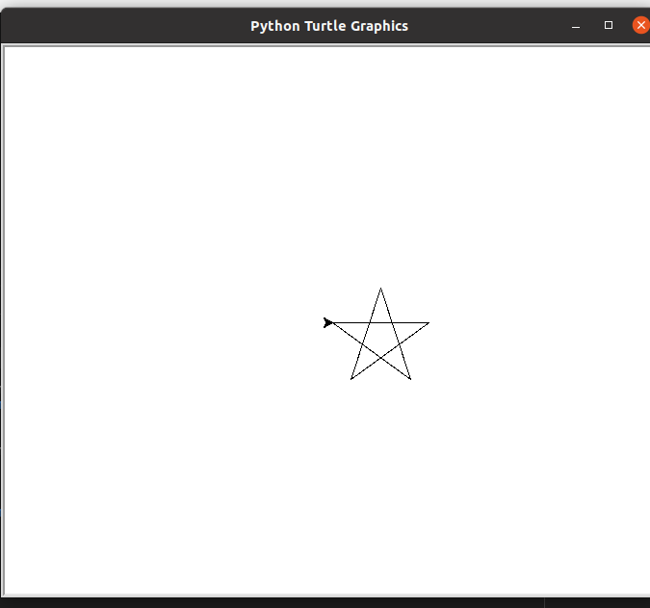

4. ROS Demonstration with TurtleSim:- Video of turtlesim is attached separately.
5. Create an Obstacle Field:-

- 10%
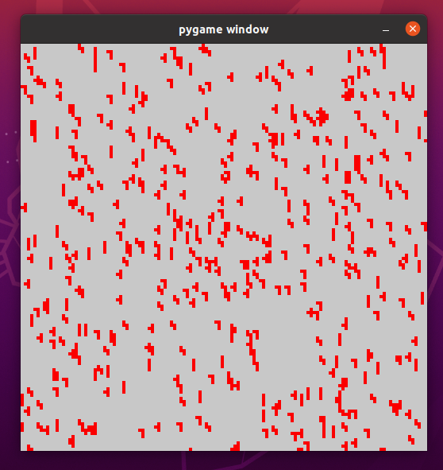

- 50%
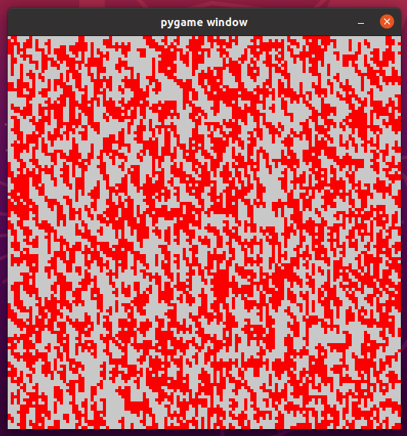

- 70%


